**STEAM USER DATABASE  
  
Problem Statement**

**Rose-Hulman Institute of Technology – CSSE 333  
  
Mike Riley  
Jack Peterson  
Tom Tao**

*signatures to be added on physical copy

**Table of Contents**

**1 Executive Summary……………………………………………………………………………2**

**2 Introduction…………………………………………………………………………………….2**

**3 High Level Problem Summary………………………………………………………………..2** Elevator Statement……………………………………………………………………...…2  
 Primary Success Criteria…………………………………………………………………..2  
 Scope………………………………………………………………………………………3

**4 Detailed Problem Statement…………………………………………………………………..3** Function…………………………………………………………………………………...3  
 Form……………………………………………………………………………………….3  
 Economy………………………………………………………………………………..…3  
 Time…………………………………………………………………………………….…4

**5 Key Stakeholders……………………………………………………………………………....4**

**6 References……………………………………………………………………………………....5**ER Diagram…………………………………………………………………………….….5

**7 Glossary………………………………………………………………………………………...5**

**1 Executive Summary**

This document’s purpose is to describe the problem that our project will solve. It has been created in conjunction with an Entity Relationship (ER) diagram. This document is the first document describing the problem, to be followed by several others, as covered in the introduction. This document also contains a high level problem summary, a detailed problem statement, and some information about the stakeholders.  
  
  
Video games are one of the most popular pieces of entertainment media. The gaming industry is a multi-billion dollar industry in this day and age, and more people are playing video games every day. Many youths and young people play games, and they need a tool that helps them find people to play those games with in a detailed manner. The methods used are a little tedious, and they don’t provide information about users in one cohesive user interface. Our goal is to save a user’s time and provide an interface that allows users to easily browse and find people who share owned games, groups, interests, and gaming wish lists, specifically users on the Steam Client. Our software solution will allow us and our users to achieve this goal. This interface will be the only place Steam users will need to go for social browsing amongst other gamers.  
  
  
**2 Introduction**

This document is the first document describing our Steam User Database (SUD) management system. We have also included an ER diagram. Along with the ER diagram, we will include a relational schema, a security analysis, periodic reports, and a final presentation. This document will give an overview of the proposed system and its requirements, and the security and data analysis will go into more detail once the system is further implemented. The relational schema will describe the database and foreign key constraints, based upon the ER diagram. The final presentation will demonstrate the completed system, as well as describing the process we used in creating the system.  
  
  
**3 High Level Problem Summary**

*3.1 Elevator Statement*

We are designing a database to keep track of peoples Steam accounts. By using Steam people are expecting one place to buy and play games, as well as talk to friends and meet new friends to play these games with. Our goal is to create a system to allow for gamers to do all of this in one place easily, and make it easy for a user or game developer to see information on their game.

*3.2 Primary Success Criteria*

Our primary goal is to create a system that can keep track of everything in Steam, including games, users, developers and user groups. For this project to be successful there has to be an efficient method of tracking all of this data, and it has to be completed by the end of spring quarter 2017.

*3.3 Scope*

1. Users

2. Companies

## **4 Detailed Problem Statement**

## *4.1 Function*

1. Ability to store gaming data for all users who are in RHIT user group, updating the data as needed (when it changes, like new achievements)
2. Will store user’s information including their groups, friends, wish list, achievements, and reviews.
3. Will store game’s information including their publishers/developers, news/announcement.
4. Ability to acquire popular games/game types among RHIT students through database
5. Ability to build a relation between games and student gaming activities
6. Ability to sort students into certain groups such as: passionate gamers, FPS shooters, frequent purchasers, etc.
7. Ability to estimate an account’s value based on its games, achievements, etc.
8. Ability to suggest a user to another user, a new game to purchase.
9. Ability to limit data access only to registered users.
10. Ability to log in and log out of sessions.

## *4.2 Form*

1. Availability
   1. Web based, for better user accessibility
   2. Secure access, limit data to RHIT student only.
2. Usability
   1. Quick access to database, fast response time to users’ searches
   2. Intuitive for user usage, clear information/help page provided
3. Performance
   1. Should be able to support multiple users simultaneously.
   2. Should be able to reject malicious searches to block server usage
4. Security
   1. Although this data might not be extremely sensitive, this database should still be able to protect itself from basic attacks, such as frequent request and tampering with data. Login function should be able to avoid malicious users.
5. Maintainability
   1. System must easily adapt to any possible user data and give concerns to some special cases, such as a game suddenly off the shelf, or a game account permanently removed from Steam.
   2. Database authorized personnel should be able to easily update data through our web server. It should be relatively easy and inform the operator whether the intended action is executed or rejected due to constraints.
6. Technology
   1. We will are tentatively looking at angular for front end development, and using MySQL to manage the database.

## *4.3 Economy*

## Marketability

This database is like a prototype marketing tool for game developers and companies. The computer game publishers might be interested in seeing a more complex solution in the future, enabling them to market their games to specific groups of people based on their user history. It would be enormously profitable since advertising is costly, and effective advertising is of utmost concern for most companies.

## *4.4 Time*

1. Historical

In the past, Steam has been the major introducer of new published games to gamers. However, their matches to users are not very accurate and mismatches “potential” customers with games that they totally dislike. Moreover, students might also be interested in knowing what games their friends are currently playing, and they need a way to know.

1. Current

Currently, there’s no easy way to figure out the favorite games of the users around us. Steam will only help users figuring out popular games among their friends. In order to build a closer bound to gamer community, location proximity is necessary. Students in a same college/university might be a good starting point to categorize users and create a database specifically for those people.

1. Future

We will continue this project by creating its functionality and increasing its algorithm in order to make this database easily adaptable for a large group. We might also be interested in marketing our database management system to game publishers, and cooperate with their needs in mind.

**5 Key Stakeholders**

|  |  |
| --- | --- |
| **Name** | **Role** |
| Sriram Mohan | Project Advisor |
| Jack Peterson | Project Team |
| Mike Riley | Project Team |
| Tom Tao | Project Team |
| Steam Users | End Users |

**6 References**

*6.1 ER Diagram*

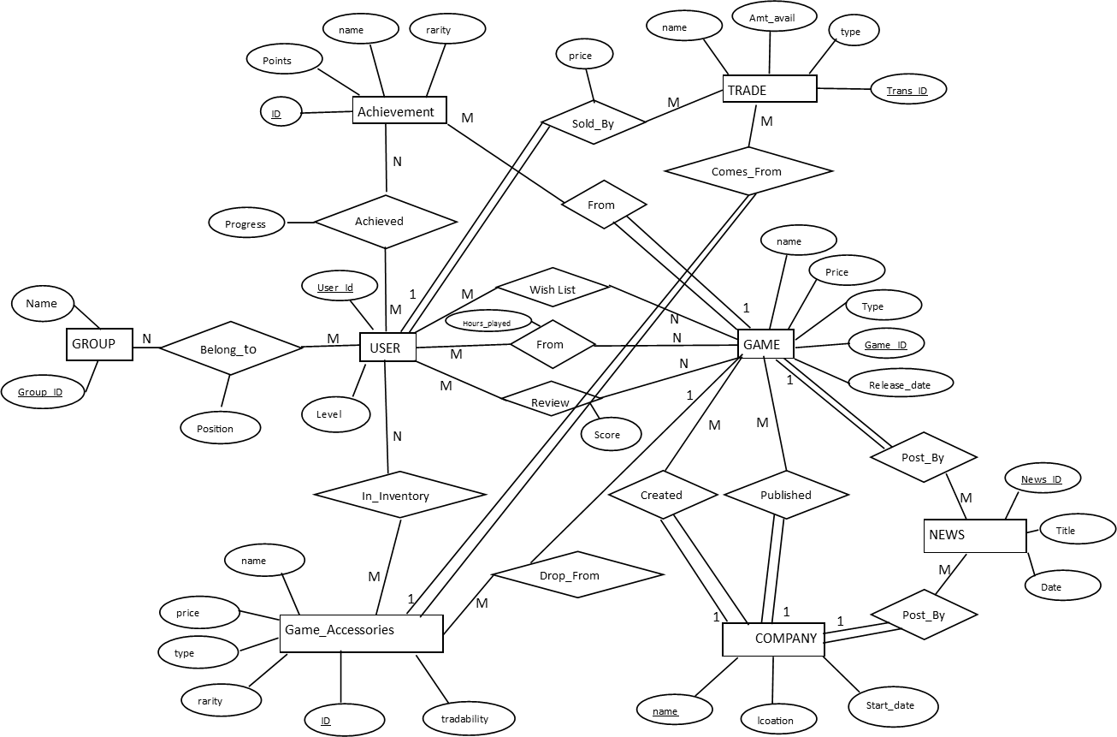

**7 Glossary**

Entity Relationship (ER) Diagram – an abstract way of representing the layout of a database

SUD – Steam User Database